Hockey Pong – Game Design Document

# Copyright Information © 2013 J. Parker

# Version history

|  |  |  |
| --- | --- | --- |
| **Time** | **Author** | **Changes** |
| **14:23 2013-08-22** | J. Parker | Create initial document |
| **9:30 2013-08-28** | J. Parker | Rev 1 Prototype 0 and 1  Art detail  Screens and transitions |
| **10:15 2013-09-02** | J. Parker | Rev 2. Prototype 2  Puck detail  Paddle detail |
| **9:45 2013-09-08** | J. Parker | Rev 3 Prototype 3  Game FSA detail  Score  Faceoff  timer |

# Table of Contents

Contents

GAME NAME 1

Game Design Document 1

Copyright Information 2

Version history 2

Table of Contents 2

Game Overview 5

Game Concept 5

Feature Set 5

Genre 5

Target Audience 5

Game Flow 5

Look and Feel 5

Project Scope 5

Number of locations 5

Number of levels 5

Number of NPC’s 5

Gameplay and Mechanics 6

Gameplay 6

Game Progression 6

Objectives – What are the objectives of the game? 6

Play Flow – How does the game flow for the game player 6

Mechanics 6

Physics – How does the physical universe work? 6

Movement 6

Objects 6

Screen Flow 7

Screen Flow Chart – A graphical description of how each screen is related to every other 7

Screen Descriptions – What is the purpose of each screen? 7

Game Options – What are the options and how do they affect game play and mechanics? 7

Replaying and Saving 7

Cheats and Easter Eggs 7

Story, Setting and Character 8

Story and Narrative - Specific details like scripts and cut scenes may not be in this document but be in the Story Bible. 8

Back story 8

Plot Elements 8

Game Progression 8

License Considerations 8

Cut Scenes 8

Game World 8

General look and feel of world 8

Area #1 8

Characters 9

Character #1 9

Levels 10

Level #1 10

Synopsis 10

Introductory Material (Cut scene? Mission briefing?) 10

Objectives 10

Physical Description 10

Map 10

Critical Path 10

Encounters 10

Level Walkthrough 10

Closing Material 10

Interface 10

Visual System 10

HUD - What controls 10

Menus 10

Rendering System 10

Camera 10

Lighting Models 10

Control System – How does the game player control the game? What are the specific commands? 10

Audio 10

Music 10

Sound Effects 10

Help System 10

Artificial Intelligence 11

Opponent AI – The active opponent that plays against the game player and therefore requires strategic decision making (example, Civilization or Chess, how is it to be designed? 11

Enemy AI – Villains and Monsters 11

Non-combat Characters 11

Friendly Characters 11

Support AI 11

Player and Collision Detection 11

Pathfinding 11

Technical – This may be abbreviated with most in the Technical Bible. 11

Target Hardware 11

Development hardware and software 11

Development procedures and standards 11

Game Engine 11

Network 11

Scripting Language 11

etc. 11

Game Art - This may be abbreviated with most of the content in an Art Bible. 11

Concept Art 11

Style Guides 11

Characters 11

Environments 12

Equipment 12

Cut scenes 12

Miscellaneous 12

Secondary Software 12

Editor 12

Installer 12

Update software 12

Management 12

Detailed Schedule 12

Budget 12

Risk Analysis 12

Localization Plan 12

Test Plan 12

Appendices 12

Asset List 12

Art 12

Sound 12

Music 13

Voice 13

Game Overview

Game Concept

Hockey Pong is a 2D two player arcade type game in the style of the original Pong. The play elements of the game are quite similar to Pong: an animated ball (puck) moves left to right across the screen, bouncing off of the sides of the playing area. If this ball passes through a goal area on the left or right end of the screen then a point is scored, and play starts again with a face-off.

Unlike the standard Pong, there will be three 2-minute long periods of play. The play ceases at the end of each period for a few seconds, followed by a face-off. Can you score more points than your opponent in three 2 minute periods?

Feature Set

* Like real hockey, a timed game rather than first past the post.
* Select your team and their logo appears on the ice.
* Two players or one player against the computer.
* Sound effects and music.
* Playable on a PC, Mac, Linux, or online through a web page.
* Variable speeds. The puck changes speed to simulate tempo changes in real hockey.
* Replayable. As the player gets better, their score improves. The AI player has adjustable levels.
* Face off after goals and at the start of each period.

Genre

Arcade, two player or one player against the computer.

Target Audience

Younger players (under 15) and casual gamers generally. Hockey or Pong fans of all ages. This has potential as an advergame, and could be played online through a browser or on a mobile device.

Game Flow

After an initial splash screen, the game begins with a traditional hockey face-off: the referee (invisible) will blow a whistle and drop the puck at center ice. The player who responds to that most quickly takes possession of the puck, and it moves towards the opponent’s end. The players control a ‘goalie’ using the keyboard, and can move him up and down the screen. The idea is to have the goalie block the puck from entering your own goal, at which point it bounces and moves towards the opposing goal. The speed of the puck varies with each collision, and the bounce direction is slightly random too. After two minutes the play stops, and a new period starts with a face-off. Goals result in a face-off as well.

The winner is the player with the most points after 3 periods of play. Players can select from a few parameters on the initial splash screen, including the home team logo to be placed on the ice (playing surface).

Look and Feel

The game is played on a flat surface made to look like a hockey rink. Key presses are used for control and sounds are used to convey the ambiance of a hockey arena.

Project Scope

Locations

Just one.

Levels

Just one, but three periods.

Non-player Characters

No actual non-player characters, but the player may play against the computer, which will then take over the controls on the right side of the game.

Gameplay and Mechanics

The basic mechanic of both hockey and Pong is to get the ball/puck past a straight line in space that is being guarded by your opponent. T\In this game the player on the left attempts to get the puck past a vertical line on the right side of the screen, and the player on the right tries to get it past a line on the left of the screen.

Gameplay

There is a puck and two paddles, one paddle on each side of the screen, Each player can move a paddle, the left player by using the ‘w’ and ‘s’ keys, and the right player by using the up and down arrow keys. The puck moves mainly left and right, but can bounce off of the sides of the ‘rink ‘ and will certainly bounce off the paddles or goalies.

Objectives – What are the objectives of the game?

The player scores a point if the puck passes over their opponent’s goal line. The player with the most points after six minutes of play, that is 3 two minute periods, wins the game.

Mechanics

The ‘w’ and ‘s’ keys control a paddle on the left side of the screen. The arrow keys control a similar paddle on the right. Each player tries to avoid having the puck pass their goal area by moving the paddle so that the puck bounces off of it. The puck will bounce back and forth until one player misses. The player who let the puck pass their scoring line does not get a point, the other player does.

There is no maximum score.

A goal cannot be scored after time has expired in any given period. A horn will sound to indicate that time is up.

Each goal has lights to indicate whether a goal has been scored. A green light indicates ‘yes’, red indicates ‘no’. The red light goes on after the time for any period is over.

What are the rules to the game, both implicit and explicit. This is the model of the universe that the game works under. Think of it as a simulation of a world, how do all the pieces interact? This actually can be a very large section.

Physics – How does the physical universe work?

This universe is 2D with no friction. The puck moves at various speeds but does not cease motion, as a real puck would, if it is not touched. There are no hockey players on the rink as there would be in real situations, so the bounces and speeds are somewhat random to account for this lack. The play is made less predictable by the existence of real players, so this game uses random speed and bounces to introduce that aspect to the play.

Movement

#### General Movement

The puck can move left and right, and to a lesser degree up and down, and does not stop moving unless a goal is scored or a period ends.

The puck starts moving after a face-off, in the general direction of the goal of the player who lost the face-off.

The puck will bounce off of the rink side and ends (the ‘boards’) in a somewhat predictable manner, but with small degrees of randomness introduced.

The paddles move only up and down, under user control.

#### Other Movement

Unlike the original Pong, the entire end of the rink is not the goal area. A goal is scored only if the puck passes one of the end red lines between a pair of ‘goal posts’ that represent the net of a hockey goal. If the puck hits the end boards it bounces, and if it hits the back of the goal it bounces.

The puck also bounces off of the paddles, which represent the goalie.

Objects

#### Picking Up Objects

No objects in this game can be picked up.

#### Moving Objects

The objects that move are the paddles and the puck.

Screen Flow

Screen Flow Chart – A graphical description of how each screen is related to every other

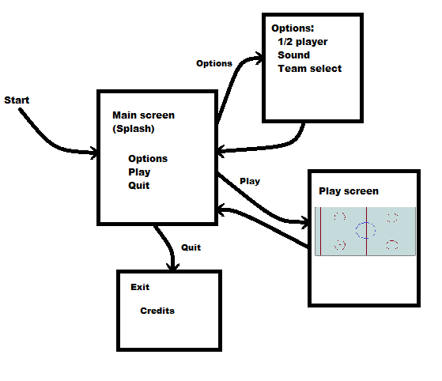

Screen Descriptions – What is the purpose of each screen?

#### Main Menu Screen

Begins when the game starts. Allows the player to navigate to the other screens, especially the play screen. **All screens use the font “@Kozuka Mincho Pro EL”,** a standard font in Paint.

Main menu has three buttons for transitions; each button is an image, and has an armed and unarmed form. They are:

Button function Unarmed Armed Coordinates

Transition to Options screen options.gif optionsA.gif 56, 400

Transition to Play screen play.gif playA.gif 341, 400

Transition to Quit screen quit.gif quitA.gif 630, 400

#### Options Screen

Permits the player to adjust the audio, select a team, and choose 1 or 2 players. This screen has two buttons for option specification and four logo images that can be selected like radio buttons. Each button is an image, and has an armed and unarmed form. They are:

Button function Unarmed Armed Coordinates

Select 2 player single.gif singleA.gif , 400

Select 1 player double.gif doubleA.gif 341, 400

Sound On soundOn.gif soundOnA.gif 630, 400

Sound Off soundOff.gif soundOffA.gif

Logo 1 OHC_logo.gif 461, 350

Logo 2 victorias.gif 536, 350

Logo 3 logo3.gif 611, 350

Logo 4 logo4.gif 686, 350

#### Play Screen

The game screen itself, showing the play surface and controls.

#### Exit Screen

Allows credits, advertising if an advergame, and could display a high score table.

Game Options – What are the options? How do they affect game play?

**Option 1: two player/one player**

Obviously, if the player selects a one player game then the game itself has to play the other paddle. This requires a bit of intelligence, and more code, but insofar as game play is concerned the main issue is face-off management. Clearly the computer can always win the face off, and if it does the player will suspect it is cheating. Thus, in the one player game the winner of a face-off is determined by a coin toss (random number < 0.5).

**Option 2: Music on/off**

Music here refers to background music, not sound effects. No consequences for game play.

**Option 3: Home team selection**

The player may select from a set of teams to be theirs, and the logo for that team will appear in the arena. In a real commercial game, a license would be required for the display of a team’s logo within the game. There is no impact on play here.

Replaying and Saving

Games cannot be saved. It’s only 6 minutes long.

Cheats and Easter Eggs

None.

Story, Setting and Character

** There is no story in this game, but many do have. If there is a narrative, it would have to be defined carefully, and this is the place in the GDD where that is done. Cut scenes are short pieces of animation that are used as a transition and a narrative device. They don’t affect play directly, but do convey story elements and tell the player needed information as well as indicate where they are in the game and what future actions might be important. **

## Story and Narrative

### Back story

### Plot Elements

### Game Progression

### License Considerations

### Cut Scenes

#### Cut scene #1

##### Actors

##### Description

##### Storyboard

##### Script

Game World

Anyone who has been at a professional sporting event would understand the feel we’re going for, but it is a two dimensional world. What can we do? The space will be presented to the player in sound.

General look and feel of world

The nature of a hockey rink is well understood. The playing surface is ice, generally a blue white color. Pucks are black rubber. The seats where the audience sits are not visible, so the sounds of the audience must be made available.

In some games there are multiple locations where play takes place. In those games, the following sections would be important:

Area #1

###### Description

Characteristics

###### Which levels use this area

###### Transitions to other areas

Characters

Again, this game has no characters to speak of. Many games do, and these must be described:

### Character #1

#### Back story

#### Relevance to story

#### Personal Traits

#### Look

##### Physical characteristics

#### Special Abilities

#### Relationships (to other characters)

#### Characteristics

Levels

** This game has a single level. In multiple level games, the significance and characteristics of each level has to be made quite plain in detail. Indeed, there are special designers called level designers who are responsible for individual levels, and who will fill in the details of these sections. **

## Level #1

### Summary

### Introductory/Transition Material for Player

### Objectives

### Physical Description

### Map

### Encounters/Tasks/Objects

### Walkthrough

Interface

** This game has a simple interface. In more complex games, there will be sections at this place in this document for special rendering systems, lighting, camera models, and special items like a heads-up display (HUD), mini-map, and other features. **

## Control System

Controls, as with all arcade games, are simple. The motion keys are used for play. The mouse is only used (in the PC/Web versions) to select screens.

## Audio

Sound is not necessarily high quality, but is an essential part of this game. We’ll use the **simpleAudio** system (developed in Chapter 3) for sound display, and don’t really need positional audio. There will be an ambient area/audience sound played at a low level while play is ongoing.

## Music

Music is limited to the main and exit screens, and will be a typical athletic anthem.

## Sound Effects

There are many sound effects for this style of game. Needed are:

* Sound of puck bouncing off of the boards
* End of period horn
* Puck hitting a stick
* Puck hitting the goal post
* Referee whistle
* Puck hitting the ice/face-off
* Audience, ambient
* Audience, approval
* Audience, angry
* Audience, goal cheer.
* Audience chant
* Horn in audience
* Organ, between face-offs
* Body check

## Help System

None.

## Scoreboard

This is for displaying game information to the player. The information displayed includes the time remaining in the current period, the period number, the score for each player, and a live play indicator, a circle either red or green. A copy of the play indicator will be displayed at the left and right ends of the rink as well. When this light is green play is taking place and a goal can be scored. When the light is red no goal will be counted. The light is set to red after a goal is scored and at the end of any period; it is set to green when the puck hits the ice during any faceoff.

Artificial Intelligence

Opponent AI

We have the NPC stay still unless the puck is moving towards the right and has passed a specified X coordinate, initially 420. This looks better, but the NPC still always wins. Setting the motion point at X=600 seems realistic, but playtesting will tell. The relevant code is quite short:

if (players == 0 && dx>0) // NPC on and puck moving right

{

if (puckX > 600) // Movement threshold distance

{

if ((rpaddley+15)-puckY > 8) // Move paddle up

rpaddledy = -paddleSpeed;

else if ((rpaddley+15)-puckY < 8)

rpaddledy = paddleSpeed; // Move paddle down

else rpaddledy = 0;

}

rpaddley += rpaddledy; // Move the paddle

if (rpaddley>pmaxy || rpaddley<pminy) // limits?

rpaddley -= rpaddledy; // Move it back

rect (rpaddlex, rpaddley, 10, 30); // Draw the paddle

}

Faceoff

When a faceoff begins a timer starts, set to a random short duration (2-4 seconds). At the end of that time the play light is set to green and play begins. The first player to type a movement key wins the faceoff, and the puck moves away from their goal. The NPC wins with a probability of 3/100 in each frame following the drop. After the faceoff the game enters the play state.

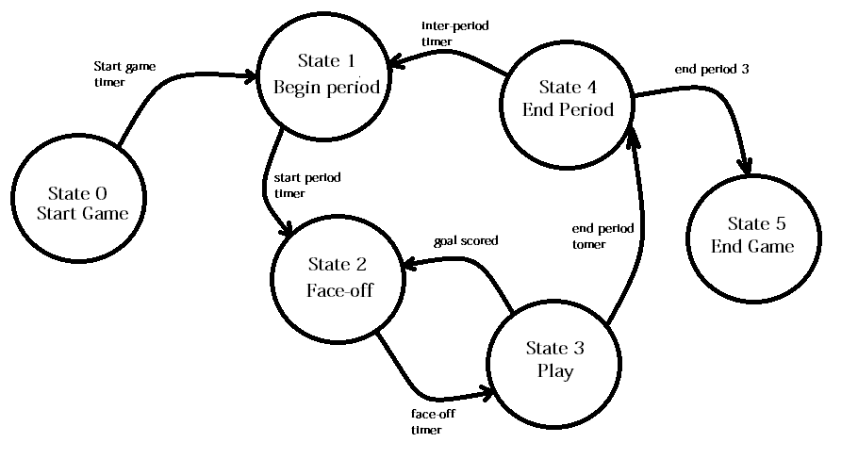Game states and transitions

There are six internal game states.

Timers are used to give a decent spacing between the transitions. Also, some are based on internal variables: period transitions depend on what period it is, for example. After a goal is scored (play state) we move to a faceoff state.

Support AI

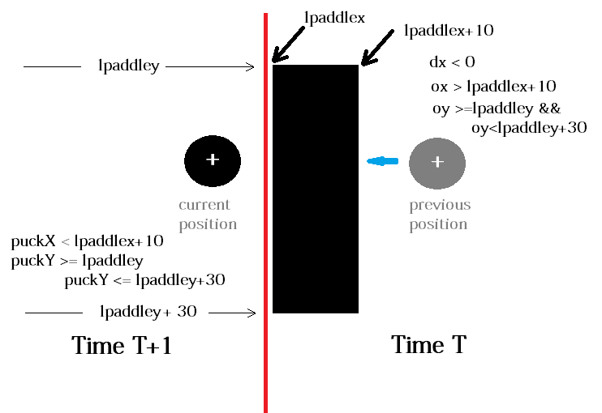Player and Collision Detection

Collision detection for paddles only. The puck is moving faster than 1 pixel per frame in most cases. That means that collision detection can’t be done by asking if the coordinates of the puck agree with coordinates of the paddle. The puck could go right through the paddle in a single frame, never having coordinates that agreed. What has to be done is to see if the puck is on one side of the paddle in one frame and is on the other side in the next frame. If so, then it had to have struck the paddle at some point in time between the two frames.

We don’t need to be too precise here; we just want the bounce to occur in a visually correct fashion. So, remember that the puck is a circle 10 pixels across, and a paddle is a rectangle 10 pixels wide (x) and 30 pixels high (y). Figure 4.6 shows a schematic diagram of the situation and gives some simple code to check for the collision. As an example, the basic code for detecting a left paddle collision is:

if ((puckX<=lpaddlex+10 && ox>=lpaddlex+10) &&

(puckY>=(lpaddley-4) && puckY<(lpaddley+34)) )

The offset of 4 pixels in the **Y** direction allow for the ball to hit the paddle near its corner, as the ball coordinate is that of its center.

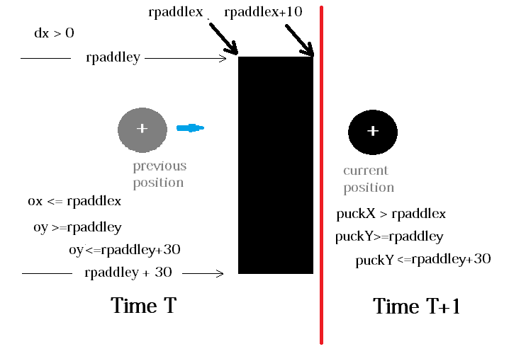

Pathfinding

None.

Technical

Target Hardware

PC, Mac, Linux. Possible conversion for web-based play.

Development hardware and software

PC, Windows 7, Processing.

Development procedures and standards

Usual Minkhollow development procedures. See manual.

Game Engine

Sound: **simpleAudio**, **source**

Network

For play, none. For development, Minknet (1 Gb)

Scripting Language

None

Game Art

Concept Art

None

Style Guides

Minkhollow media playtesting guide

Minkhollow media programming style manual (Vol 3: Processing)

Secondary Software

Editor

None

Installer

None

Update software

None

Management

Detailed Schedule (From start of project)

High Concept 2 hours

Initial prototype 1 day

Producer meeting 2 hours

Screen design 1 day

Screen Art 1 day

Buttons 3 hours

Sound (level 0) 2 days

Game screen 3 hours

User control 1 day

AI control 4 hours

Game states 2 days

Sound (level 1) 1 day

Playtesting 3 days

Total 13 days 14 hours = 15 days

Response 2 days

Budget

Design $2,000

Art $ 800

Programming $2,000

Sound $ 900

Testing $1,200

----------

Total $6,900

Risk Analysis

IP: no current logos are used, no images from outside sources, and no music or sounds that have a copyright.

Localization Plan

It is possible to include logos from any team, including professional leagues, national teams, or local pee-wee and youth leagues. This could yield a market for this as a promotional game with regional/local content.

Sound could be added that involved a short script (start screen and end screen), and local player names could easily be added to audience shouts.

Test Plan

First level testing will use the usual internal sources. Before the release, the game will be given to young people (age 12-16) in an online forum using recorded audio.

Appendices

Asset List

Art

#### Model and Texture List

All art files in **2013/hockey/Art**

No 3d models.

Ice texture ice.png

Rink rink.bmp (play surface)

rinkLarge.bmp (original art)

#### Animation List

None

#### Effects List

None

#### Interface Art List

Start screen screen0.png

Play button play.gif (unarmed) playA.gif (armed)

Options button options.gif ((unarmed) optionsA.gif (armed)

Quit button quit.gif (unarmed) quitA.gif (armed)

Option screen screen1.png

Player button double.gif (unarmed) doubleA.gif (unarmed)

single.gif (unarmed) singleA.gif (armed)

Sound button soundon.gif (unarmed) soundOnA.gif (armed)

soundOff.gif (unarmed) soundOffA.gif (unarmed)

Team Selection OCH_logo.gif, victorias.gif, logo3.gif, logo4.gif

Back back.gif (unarmed) backA.gif (armed)

Game Screen back.gif (unarmed) backA.gif (armed)

Exit screen screen3.bmp

#### Cut scene List

None

Sound

#### Environmental Sounds

Audience/arena ambience amb-aud01.mp3 1:01 amb-aud05.mp3

amb-aud02.mp3 1:02 amb-aud05.mp3

amb-aud03.mp3 1:00 amb-aud07.mp3 1:01

amb-aud04.mp3 1:03

Beginning of game: entry.mp3

#### Event Sounds

Puck hitting boards: bang00.mp3 to bang10.mp3

End of period horn: endPeriod.mp3

Referee whistle: sfx-whistle.mp3

#### Interface Sounds

None

Music

#### None. (Ambient, Victory, Defeat, …)

Voice

Scripts and stage directions for any voiceover work. There is none here at this time.